Fund Manager Quick-Start Guide
Table Of Contents

Introducing Fund Manager 3
Getting Started Tutorial 3
Retrieve Historical Transactions and Positions 3
Import Historical Transactions 14
Manually Enter Historical Transactions 21
Retrieve or Manually Enter Starting Positions 32
Import Starting Positions 40
Graphs Tutorial 50
Reports Tutorial 52
Data Register Tutorial 55
Portfolio Editor Tutorial 58
Multiple Currency Tutorial 62

Introducing Fund Manager
Welcome to Fund Manager. Fund Manager is powerful portfolio management software. Fund Manager is available in Personal, Professional, or Advisor versions for the individual investor, professional trader, or investment advisor.
This guide will demonstrate the basics of using Fund Manager to get you started quickly. For more detailed help, consult the documentation included in Fund Manager.

Getting Started Tutorial
Before starting, you should have already downloaded and installed the program onto your computer. If you haven't already installed the program, visit our download page. After installation, you can start Fund Manager by choosing "Start / All Programs / Fund Manager / Fund Manager".
Fund Manager can track an unlimited number of accounts. Each account you want to track is normally set up as its own sub-portfolio. Sub-portfolios can be hierarchical for additional organization.
When creating new investments for your account you can either record all the historical transactions, or enter starting positions as of a specified date. It is preferable to record all the historical transactions, as this enables accurate performance reporting over past time periods. In cases where the historical data are unavailable or impractical to enter, you may use the starting positions. Historical transactions can be retrieved automatically, imported from a file, or entered manually. In order to retrieve historical transactions or positions, your account must be available from one of the supported brokerage or mutual fund companies. The term "retrieve" is used when Fund Manager connects via the internet and automatically obtains your data. The term "import" is used when you have your data in a file, and Fund Manager reads in the data from this file. Fund Manager can import transactions and positions from a wide variety of files.
There are many ways to initially get your data into Fund Manager:
(Jump to the section you wish to read about by selecting one of these)
- Retrieve Historical Transactions and Positions
- Import Historical Transactions
- Manually Enter Historical Transactions
- Retrieve Starting Positions
- Import Starting Positions
- Manually Enter Starting Positions

Retrieve Historical Transactions and Positions
First, close any sample data that you may have open by selecting the menu command "File / Close Portfolio". Next, open the New Portfolio Wizard by selecting "File / New Portfolio Wizard..." and fill in the information for your account:
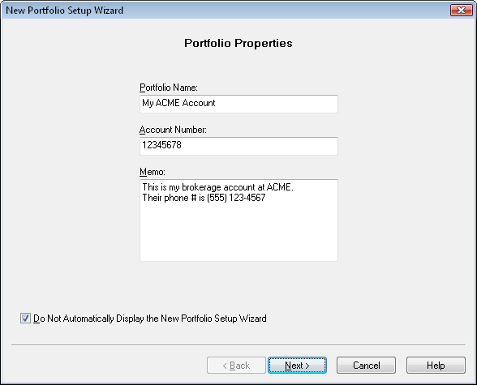
Press "Next", choose your broker or fund company, and enter your login information:
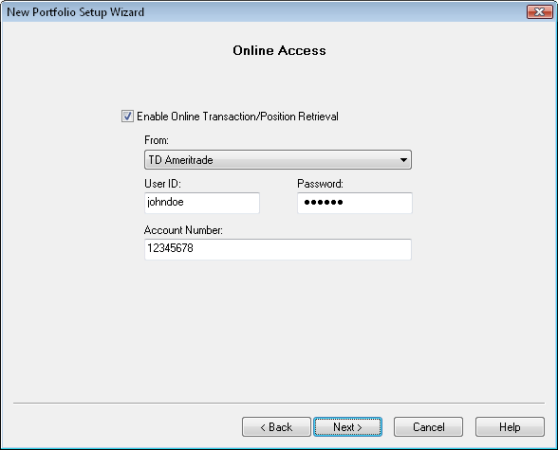
Press "Next" and choose the option to "Retrieve Transactions and Positions":
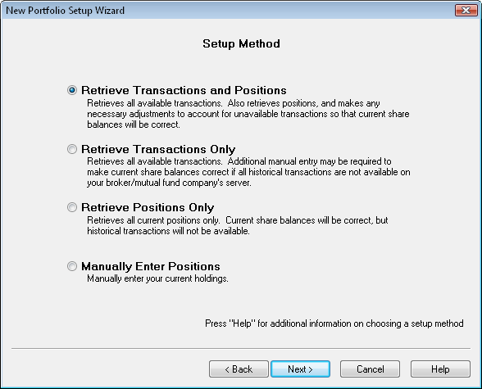
Press "Next" and your historical transactions and current positions will be retrieved. You will see the status displayed during the retrieve:
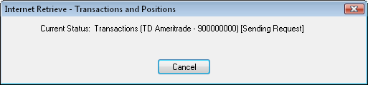
When the retrieve is complete you can choose which investment should be your default cash account:
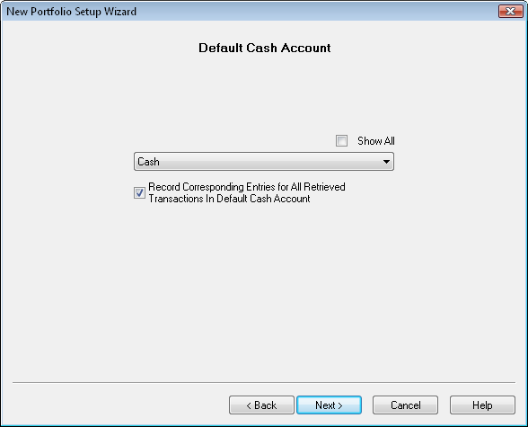
Press "Next" and review your retrieved positions:
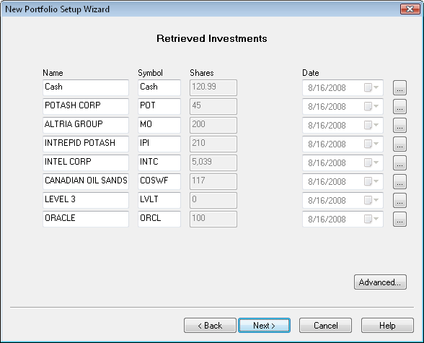
Press "Next" to update prices for your account:
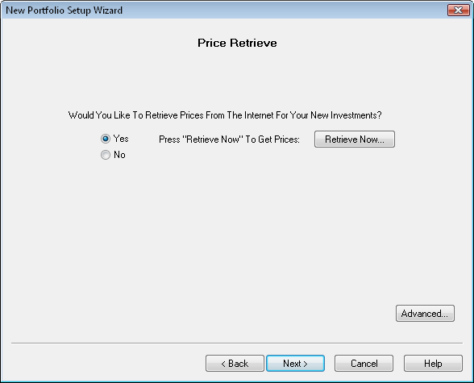
To retrieve historical pricing data for your portfolio, press the "Retrieve Now..." button:
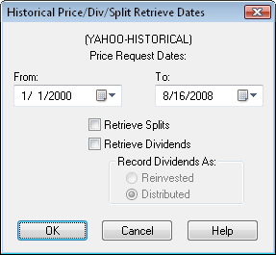
Retrieve pricing data for as far back as you need. If you are using the Professional or Advisor versions you will also see the options to retrieve splits/dividends. Since we already retrieved this data from the broker/mutual fund company leave these options off here. Once price updating is done, press "Next" and choose an option similar to below:
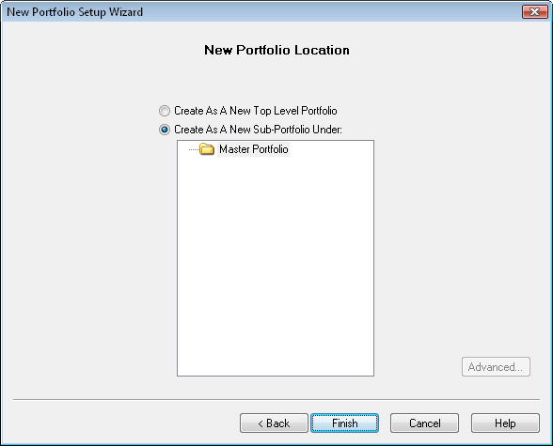
Press "Finish" to complete the setup. Your new sub-portfolio will be displayed in the Portfolio Editor.
Next, we'll reconcile this account to verify all the balances are correct. Right mouse click on your new sub-portfolio in the Portfolio Editor, and choose "Reconcile..." from the popup menu:
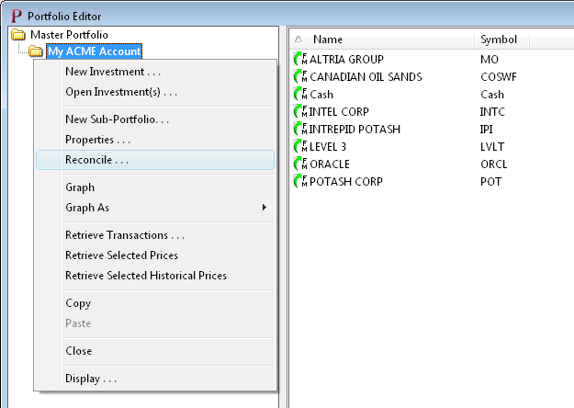
This will bring up the Reconciliation Wizard:
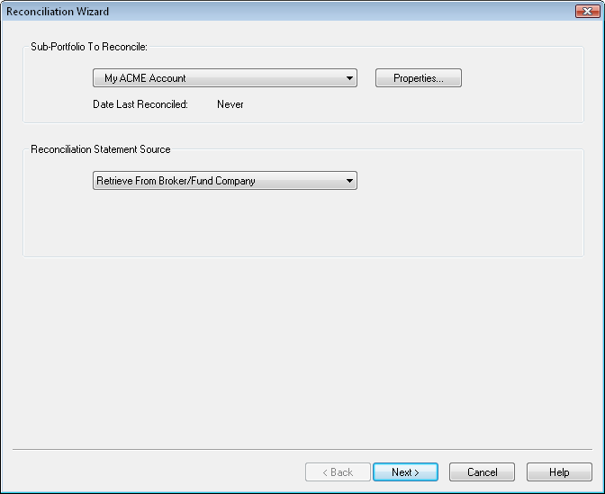
Set the reconciliation source to "Retrieve from Broker/Fund Company" and press "Next". Fund Manager will retrieve a position statement from your broker, and display the results of the reconciliation:
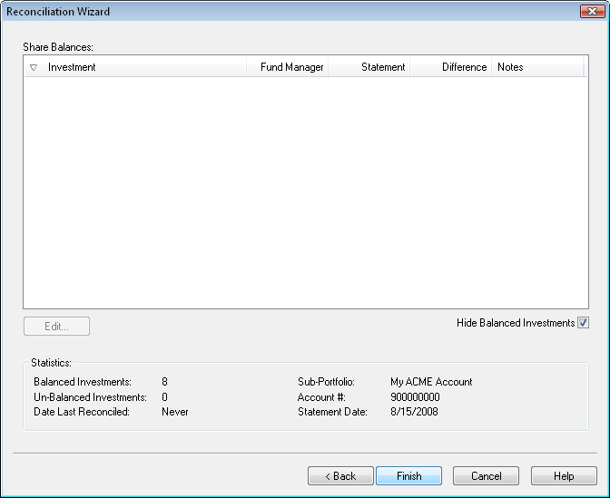
Since we just retrieved transactions and positions, everything should balance. If there were any investments that have an incorrect share balance, select the investment in the list and use the "Edit..." button to open up the Data Register so you can add/edit/delete any necessary transactions. Press "Finish" to complete the reconciliation.
If you have some investments in your account that you no longer own, you may want to hide them. You can repeat the above process to set up any additional accounts.
Now we will save our data.
Background on Fund Manager Data Files:
There are 2 types of data files used by Fund Manager:
- Investment files
- Portfolio files
Investment files have the file extension of *.dat. Investment files store pricing, transaction, and the properties for that investment. (more info)
Portfolio files have the file extension of *.mm4. Portfolio files store all of your sub-portfolios, which investment files belong in each sub-portfolio, which windows you have open, and all of your options. Portfolio files can be thought of as saving your whole workspace. When you re-open a portfolio file, all of the included investments are also opened. The windows you had open when you last saved the portfolio file are also re-created, and all your settings are restored to their values when you last saved the portfolio file. In short, everything is restored to the same state as when you last saved the portfolio file. (more info)
In many cases you will only need to have a single portfolio file, but you will have many investment files.
Choose the File / Save All Investments menu command to save your investments. Choose File / Save Portfolio As... to assign a portfolio filename and save it.
The next time you start Fund Manager, the last portfolio file you had open will automatically be opened for you. Exit Fund Manager now, by choosing File / Exit. Restart Fund Manager by choosing Start / All Programs / Fund Manager / Fund Manager, and you will see your portfolio again, just as you last left it.
Now that we've created some data let's examine our investments with various reports and graphs:
Reports Tutorial
Graphs Tutorial
See Also:
- Portfolio Editor Tutorial
- Data Register Tutorial

Import Historical Transactions
In this tutorial section we will go through the following steps:
- Import historical transactions
- Retrieve historical pricing
1. Import Historical Transactions:
First, close any sample data that you may have open by selecting the menu command "File / Close Portfolio".
Before importing, you must obtain the file containing your transaction history. This can be obtained in a variety of ways, but some common ways include:
- Export from prior software, such as Quicken or Money
- Download from your broker or mutual fund company's web site
- Advisors can obtain a file from any of our supported broker/dealer interfaces
For more details on any of the supported file import formats see the Importing Transactions topic in the documentation.
Once you have your transaction history file select the appropriate menu command from the "File / Import / Transactions" menu:
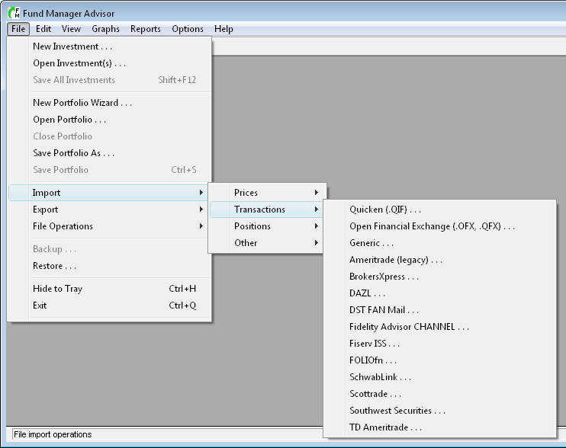
For this tutorial we'll use the "Quicken (*.QIF)" format. Once you select one of the above menu commands, you'll see the appropriate transaction import dialog:
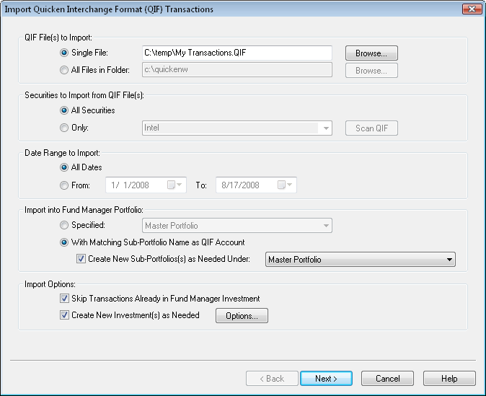
In the first section of this dialog you can choose to either import a single file, or all files in a directory. If you choose "All Files In Folder", all files in that folder with the .QIF extension will be imported. In this example we're just importing a single file (My Transactions.qif).
In the second section you can choose whether to import all available securities, or only a specific one. We'll import all securities.
In the third section you can choose to only import transactions for a certain date range or all dates. We'll import transactions for all dates.
In the "Import into Fund Manager Portfolio" section, you specify the sub-portfolio where transactions will be imported into. Select a specific sub-portfolio, or have Fund Manager match the account from the importing file with the sub-portfolio property. When this "matching" option is selected you can choose the "Create New Sub-Portfolios as Needed" option to have new sub-portfolios created when a matching sub-portfolio cannot be found. The method used to determine an account / sub-portfolio match varies depending on the type of data you are importing. Usually this is based on account number. Since we don't have any sub-portfolios created now, Fund Manager will create them for us.
In the "Import Options" section you can choose to have Fund Manager skip over transactions already in Fund Manager. This is useful when re-importing a file that may have already been imported. Matching transactions are based on an exact match of date, price, and shares. You also have the option of creating new investments automatically. With this option on, Fund Manager will automatically create any needed new investments. Normally this option is left on.
Press "Next" to perform the import. The import results will be available for previewing:
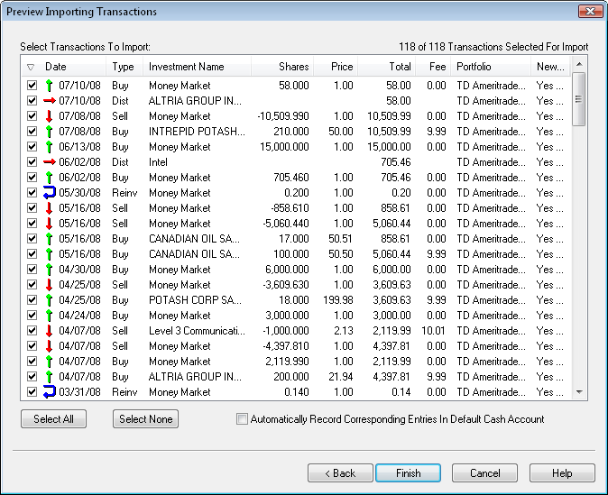
The transactions you are about to import are listed. If for any reason you don't want to import one or more transactions, remove the check mark next to that transaction. We'll leave them all selected for this tutorial.
When importing transactions there is an option "Automatically Record Corresponding Entries In Default Cash Account". When this option is turned on, and a transaction is in a sub-portfolio with an assigned default cash account, Fund Manager will automatically debit/credit this cash account for any transaction that generates or uses cash. If your importing data already includes these cash account transactions, you would want to turn this option off, so as to not double enter these transactions. This sample data already includes cash account transactions, so we will leave this option un-checked. Whenever a new sub-portfolio is created due to an import, you will be prompted to assign a default cash account, as shown in the next picture.
Press "Finish" to complete the import. For each new sub-portfolio that is being created, you will be prompted for how you would like to handle the default cash account:
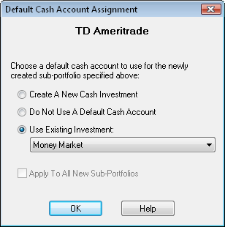
Each sub-portfolio can have its own default cash account assigned to it. When a sub-portfolio has an assigned default cash account, any transactions recorded in that sub-portfolio will automatically have corresponding entries recorded in the cash account. For example, if you buy some shares of an investment, the proceeds will come out of the default cash account. For mutual fund accounts it is usually not necessary to use a default cash account, but for brokerage accounts you usually do want a default cash account.
If you choose the first option, "Create A New Cash Investment", Fund Manager will create a new investment and assign it as the default cash account for the specified sub-portfolio. If you choose the second option, "Do Not Use A Default Cash Account", no cash account will be used for this sub-portfolio. If you choose the third option, "Use Existing Investment", you can pick from any of the existing investments in this sub-portfolio to be the default cash account. You can always modify the default cash account assignment at any later time by selecting the "Properties..." of the sub-portfolio.
Click OK after making your selection, and repeat for each new account/sub-portfolio. You will then see the main window look something like this:
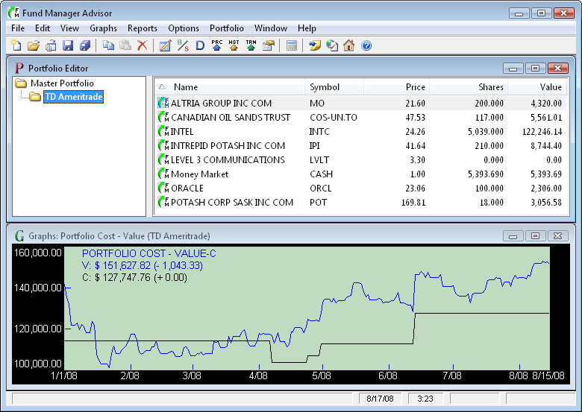
2. Retrieve Historical Pricing:
Some import file formats contain pricing data in addition to transactions. For cases where you do not get prices imported, we will now retrieve historical pricing data. Even if your import did contain pricing, it is okay to also retrieve prices. Fund Manager can retrieve prices from a variety of quote servers. In order to get historical prices we will select "Yahoo (Historical)" for our historical quote server. Choose "Options / Internet Settings..." from the menu and choose this historical quote server as shown here:
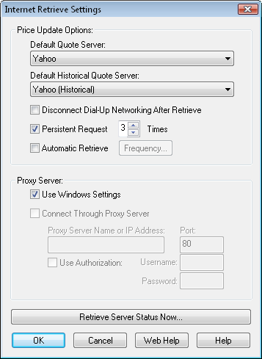
Press OK. To retrieve historical pricing data for all open investments select the menu command "Edit / Internet Retrieve / Historical Prices..." or choose the button on the toolbar.
A dialog will come up asking you for a date range for retrieving historical prices. Enter the date range you would like, and select OK. You will see Fund Manager connect to the quote server and retrieve prices. You can view all the retrieved pricing data in the Data Register.
Once you have historical pricing, use the regular server for obtaining daily quotes. It is best to use a "daily" quote server instead of a historical one for fast retrieves. To retrieve using the regular server select the menu command "Edit / Internet Retrieve / Prices..." or choose the button on the toolbar.
In this tutorial we used the "Edit / Internet Retrieve / Historical Prices..." menu command to retrieve prices for all investments. You can also retrieve prices for only select investments by selecting them in the Portfolio Editor, right mouse clicking, and choosing "Retrieve Selected Prices" or "Retrieve Selected Historical Prices".
Now we will save our data.
Background on Fund Manager Data Files:
There are 2 types of data files used by Fund Manager:
- Investment files
- Portfolio files
Investment files have the file extension of *.dat. Investment files store pricing, transaction, and the properties for that investment. (more info)
Portfolio files have the file extension of *.mm4. Portfolio files store all of your sub-portfolios, which investment files belong in each sub-portfolio, which windows you have open, and all of your options. Portfolio files can be thought of as saving your whole workspace. When you re-open a portfolio file, all of the included investments are also opened. The windows you had open when you last saved the portfolio file are also re-created, and all your settings are restored to their values when you last saved the portfolio file. In short, everything is restored to the same state as when you last saved the portfolio file. (more info)
In many cases you will only need to have a single portfolio file, but you will have many investment files.
Choose the File / Save All Investments menu command to save your investments. Choose File / Save Portfolio As... to assign a portfolio filename and save it.
The next time you start Fund Manager, the last portfolio file you had open will automatically be opened for you. Exit Fund Manager now, by choosing File / Exit. Restart Fund Manager by choosing Start / All Programs / Fund Manager / Fund Manager, and you will see your portfolio again, just as you last left it.
Now that we've created some data let's examine our investments with various reports and graphs:
Reports Tutorial
Graphs Tutorial
See Also:
- Portfolio Editor Tutorial
- Data Register Tutorial

Manually Enter Historical Transactions
In this tutorial section we will go through the following steps:
- Create a new sub-portfolio using the Portfolio Editor
- Create a new investment
- Create/assign a new investment for the default cash account
- Manually enter transaction history
- Retrieve historical pricing
1. Create a New Sub-Portfolio Using the Portfolio Editor:
First, close any data that you may have open by selecting the menu command "File / Close Portfolio". If the Portfolio Editor window is not already displayed, open it with the menu command "View / Portfolio Editor". Right mouse click on the top level sub-portfolio (Master Portfolio) and choose "New Sub-Portfolio" from the popup menu as shown here:
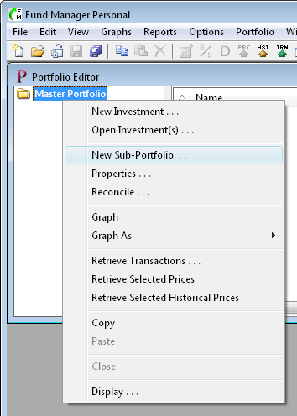
Type in a name for the new sub-portfolio and any other information you would like to remember for this account. An example is shown here:
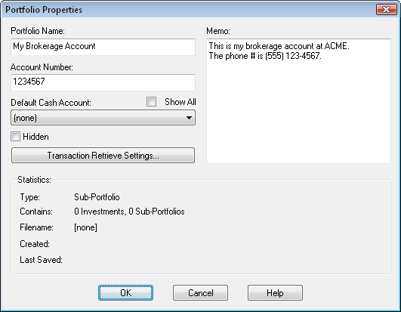
Press "OK" to create the sub-portfolio.
2. Create a New Investment:
To create a new investment in this sub-portfolio select "File / New Investment..." from the menu. Fill out the dialog with the details of this investment, as shown here:
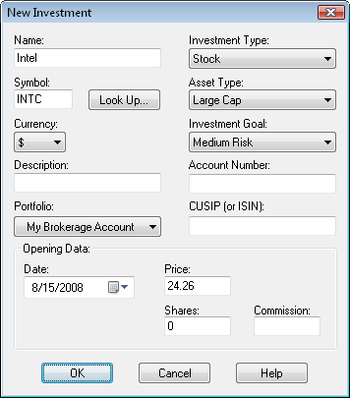
When creating a new investment you choose which sub-portfolio to place the new investment in. In this example we have placed it in our new sub-portfolio "My Brokerage Account". You can also specify an initial purchase in the "Opening Data" section. In this example we will just start off with 0 shares, and we'll record our purchases separately. Press "OK" to create the investment. You will be prompted for a filename to assign to this investment. Each investment is stored as a *.dat file. Pricing and transaction data for this investment will be stored in this file. You can give the investment any filename you want, and store it anywhere you want. The default filename is based on the symbol, but you can change it to anything you'd like. Assign the investment a filename and save it.
3. Create/Assign a New Investment for the Default Cash Account:
Now we'll create another investment that we will use as our default cash account in this sub-portfolio. Select "File / New Investment..." again and fill out the dialog to look something like this:
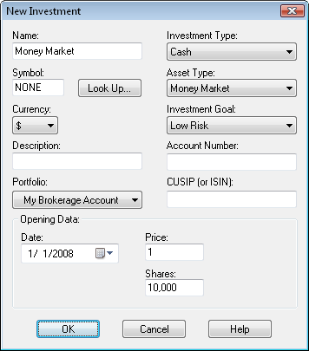
When creating cash accounts they are normally kept at a constant share price of $1. In this example we started the cash account off with a balance of $10,000 on 1/1/2008. Press "OK", assign a filename to this investment, and save it.
To assign this cash investment as the default cash account, right mouse click on the sub-portfolio in the Portfolio Editor window and choose "Properties..." from the popup menu:
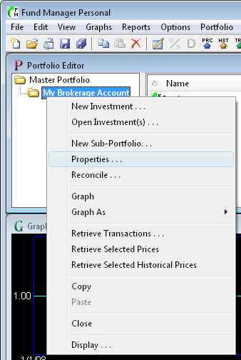
This will bring up the "Portfolio Properties" dialog, where you can select the "Money Market" investment we just created as the "Default Cash Account" for our sub-portfolio:
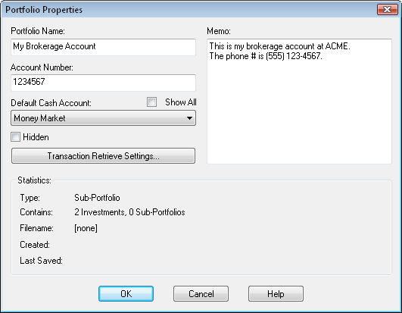
Choose OK to confirm the changes, and now the "Money Market" investment is assigned as the default cash account for this sub-portfolio. From now on, whenever you record a buy, sell, or distribution in any investment in this sub-portfolio, the money will come out of, or go into, this cash account.
An important point to note about your cash account is that proceeds are only automatically transferred to/from the cash account after you've specified which investment is your default cash account. When you are just starting out, you may want to create your cash account first, and assign it as your default cash account, prior to entering all of your other investments with their transactions. This is not a requirement, but if you'd like corresponding entries in your cash account, then you would want to do this.
4. Manually Enter Transaction History:
When we initially created the "Intel" investment we started it off with 0 shares. Now, we will go back and manually fill in the transaction history for that investment. We will manually enter the following transactions for the "Intel" investment:
- Bought 1,000 shares on 5/9/2008 for $23.37 per share ($9 commission fee)
- Received a $290 dividend on 6/2/2008
- Sold 500 shares on 8/15/2008 for $24.26 per share ($9 commission fee)
For viewing/editing/adding transactions you'll use the Data Register by choosing Edit / All Data... from the menu or selecting the button on the toolbar. You can also access the Data Register or record any transaction for an investment by right mouse clicking on that investment, and choosing the appropriate menu command. The Data Register looks like this:
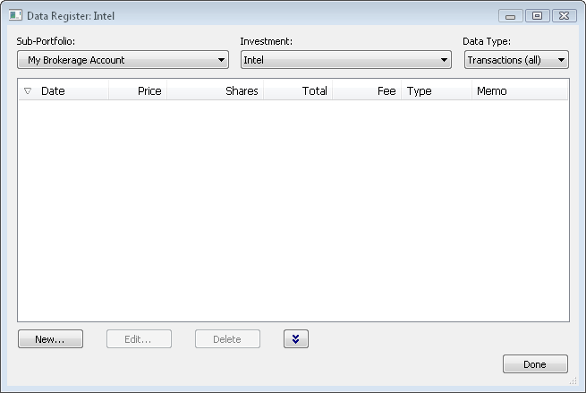
To start entering our transactions for Intel, set the "Portfolio" combo box to "My Brokerage Account", set the "Investment" combo box to "Intel", and set the "Data Type" combo box to "Transactions (all)" as shown above. You will notice under the "Data Type" combo box there are 5 top level data types: Prices, Transactions (all), Distributions (all), Splits, and Alerts. You can also select one of the sub-categories, like "Purchases", which is a sub-set of "Transactions (all)". When you select "Transactions (all)", all purchases, reinvestments, and redemptions are shown. The same concept applies to "Distributions (all)" and its sub-categories.
After making these selections, choose the "New..." button and enter the initial purchase information as shown here:
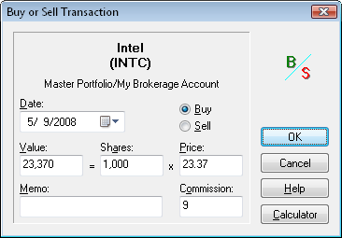
After pressing the OK button you will see your purchase listed in the Data Register. Next, to enter the distribution, change the "Data Type" to "Distributions (all)" and select the "New..." button, and then fill in the dialog as shown here:
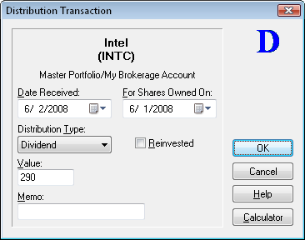
Once you click the OK button you will see your distribution added into the Data Register again. Next, to record the sell transaction, select the "Investments (all)" data type (you could also choose the "Redemptions" sub-category data type), and then choose the "New..." button and fill in the dialog as shown here:
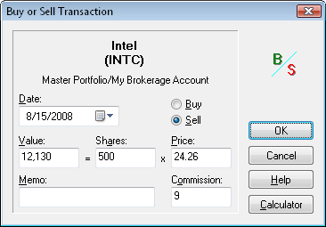
Choose OK and we've completed entering the transactions for Intel. Close the Data Register by pressing "Done".
Recording Transactions Without Rounding Errors:
Often there can be small rounding errors on your transaction summary statement, as provided by your broker or fund company. Improperly recorded, this can lead to small differences between the share balances reported by Fund Manager and your statements. To prevent rounding errors, record the Value and Shares fields in Fund Manager as displayed on your fund statement. Then, press the Tab key to move the input focus to the Price field. Fund Manager will automatically adjust the Price field to be consistent with the Value and Shares. This method records the Value and Shares as displayed on your statement. If there are rounding errors on your statement, the Price recorded by Fund Manager will be adjusted to the correct price (consistent with the Value and Shares). Fund Manager always ensures that Value = Shares * Price.
You can move the input focus around on a dialog box by pressing the Tab key on your keyboard. The order that the focus moves around on a dialog box is referred to as the "tab order". The transaction dialogs in Fund Manager have their tab order set to facilitate this recording method. The tab order in transaction dialogs moves from the Value, to the Shares, and then to the Price controls.
When recording transactions in investments that have had splits occur, record the transaction data as it occurred on the date of the transaction.
5. Retrieve Historical Pricing:
We will now update our investments with historical pricing data. Fund Manager can retrieve prices from a variety of quote servers. In order to get historical prices we will select "Yahoo (Historical)" for our historical quote server. Choose "Options / Internet Settings..." from the menu and choose this historical quote server as shown here:
Press OK. To retrieve historical pricing data for all open investments select the menu command "Edit / Internet Retrieve / Historical Prices..." or choose the button on the toolbar.
A dialog will come up asking you for a date range for retrieving historical prices. Enter the dates you would like prices for, and select OK. You will see Fund Manager connect to the quote server and retrieve prices. You can view all the retrieved pricing data in the Data Register.
Once you have historical pricing, use the regular server for obtaining daily quotes. It is best to use a "daily" quote server instead of a historical one for fast retrieves. To retrieve using the regular server select the menu command "Edit / Internet Retrieve / Prices..." or choose the button on the toolbar.
You may have noticed that pricing data for the Money Market account was not retrieved. This is because this investment was created as a "Cash" investment type, and these have the investment property to retrieve prices turned off by default. To see this, right mouse click on the investment and choose "Properties..." and select the "Internet Retrieve" tab. Normally you would not want to retrieve prices for cash investments as their price is kept at a constant $1.
Now we will save our data.
Background on Fund Manager Data Files:
There are 2 types of data files used by Fund Manager:
- Investment files
- Portfolio files
Investment files have the file extension of *.dat. Investment files store pricing, transaction, and the properties for that investment. (more info)
Portfolio files have the file extension of *.mm4. Portfolio files store all of your sub-portfolios, which investment files belong in each sub-portfolio, which windows you have open, and all of your options. Portfolio files can be thought of as saving your whole workspace. When you re-open a portfolio file, all of the included investments are also opened. The windows you had open when you last saved the portfolio file are also re-created, and all your settings are restored to their values when you last saved the portfolio file. In short, everything is restored to the same state as when you last saved the portfolio file. (more info)
In many cases you will only need to have a single portfolio file, but you will have many investment files.
Choose the File / Save All Investments menu command to save your investments. Choose File / Save Portfolio As... to assign a portfolio filename and save it.
The next time you start Fund Manager, the last portfolio file you had open will automatically be opened for you. Exit Fund Manager now, by choosing File / Exit. Restart Fund Manager by choosing Start / All Programs / Fund Manager / Fund Manager, and you will see your portfolio again, just as you last left it.
Now that we've created some data let's examine our investments with various reports and graphs:
Reports Tutorial
Graphs Tutorial
See Also:
- Portfolio Editor Tutorial
- Data Register Tutorial

Retrieve or Manually Enter Starting Positions
To create a new sub-portfolio with starting positions we will use the New Portfolio Setup Wizard. With the New Portfolio Setup Wizard you can either retrieve or manually enter starting positions.
First, close any data that you may have open by selecting the menu command "File / Close Portfolio". Select the menu command "File / New Portfolio Wizard..." to start creating our new portfolio and investments. You will be presented with the New Portfolio Wizard dialog. We will first assign properties for our new portfolio. Fill in the fields of this dialog as shown here:
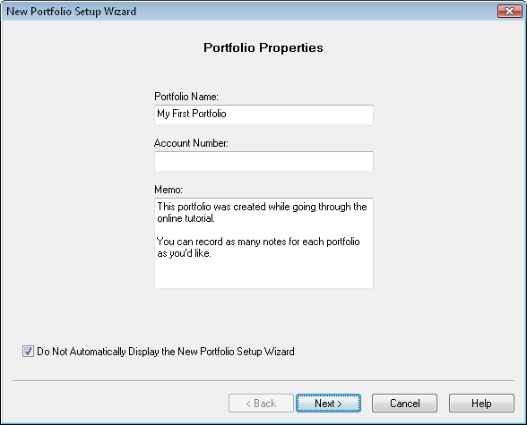
Press "Next" to enter online access details if this account is held at a broker or mutual fund company that supports retrieving positions:
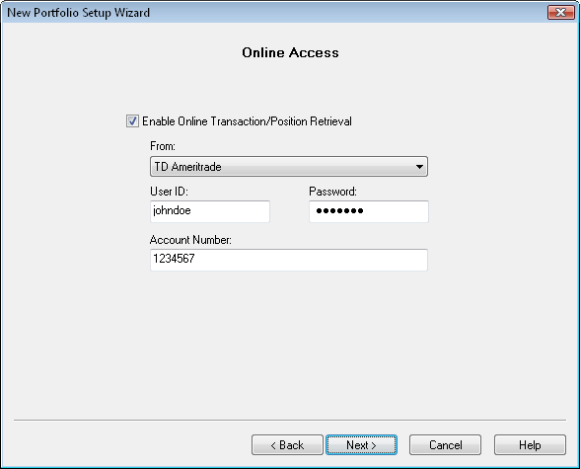
Press "Next" to select a setup method. If you have enabled online access you will have the option to retrieve your information. You can also choose to manually enter your current positions:
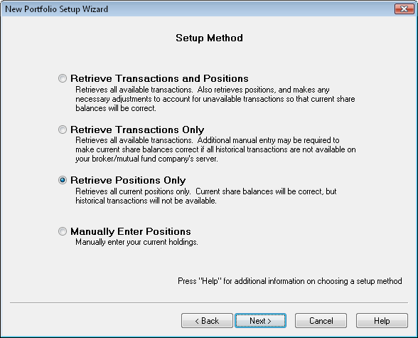
For this tutorial we will retrieve our starting positions. You can also choose to manually enter them. Press "Next" to have the positions retrieved. Once the retrieve completes you will see all your current positions:
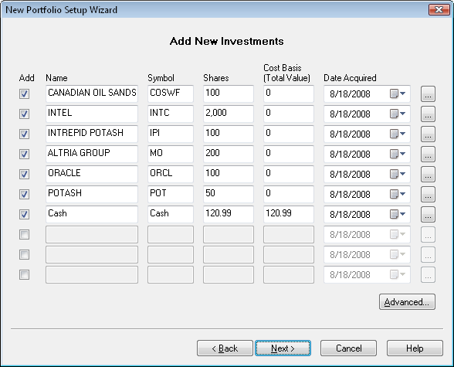
This dialog allows you to create new investments and establish their starting positions. If you retrieved positions it will be filled in for you. Retrieved positions will not show a cost basis, but you can enter the basis and date acquired here. Any of this data can always be edited later, so if you make a mistake, don't worry, you can correct it later. To add an investment, select the "Add" button for that row, and fill in the information. If you want to start your investment with a certain number of shares and cost basis, enter that information here. (Notice the cost basis is a total dollar value, not a per-share amount.) Fund Manager will record a single purchase on the specified date for the cost basis. If you'd prefer to enter your full transaction history to have a more detailed record, just record 0 for the shares now, and add in your transactions later.
You can press the "..." button at the end of each investment row to modify more properties for each investment. For example, press the "..." button to the right of the "Cash" and set the "Type" on the "General" tab to "Cash" and on the "Internet Retrieve" tab turn off the option to retrieve pricing for this cash investment. Cash investments should keep a constant $1 share price, so they don't need to be set for price retrieval.
You can press the "Advanced..." button to select a folder where your investment files will be saved. For this tutorial, we'll just accept the default location, so you don't need to press the "Advanced..." button.
You can add as many investments as you want. If you have more than will fit on the current page, when you select "Next" you will get another page to continue entering your investments.
Press the "Next" button once you're ready, and you will see the "Price Retrieve" page of the wizard:
Here you can either have Fund Manager retrieve prices for your new investments, or if you select "No", you can manually enter a price for each investment on the next screen. For this tutorial we will retrieve historical prices from the internet. You can use the "Advanced..." button to select which quote server to use. The default server when using the New Portfolio Wizard is the Yahoo (Historical) server. We will just accept all the defaults for this tutorial, so you don't need to press the "Advanced..." button.
Press the "Retrieve Now..." button, and you will be prompted for the date range to retrieve:
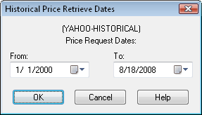
Select a date range to retrieve prices, and press the OK button. If you have a slower internet connection, you may want to choose a shorter time period than shown here. A dialog box will show the status of the internet retrieve as it is happening.
Once the retrieve is complete press the "Next" button until you see the "Default Cash Account" page:
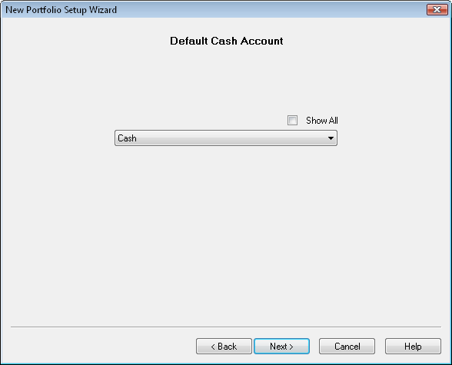
If you have a cash account in this sub-portfolio select it from the list. Otherwise, leave the selection set to "(none)". When a sub-portfolio has a default cash account assigned whenever you record a buy, sell, or distribution in an investment in this sub-portfolio, the money will come out of, or go into, this cash account.
An important point to note about your cash account is that proceeds are only automatically transferred to/from the cash account after you've specified which investment is your default cash account. If you decide later to change the default cash account you can assign it under the "Properties..." dialog for any sub-portfolio.
Press the "Next" button so that you see the "New Portfolio Location" page:
Choose the option to create this new sub-portfolio beneath the existing Master Portfolio, and press the "Finish" button.
Now we will save our data.
Background on Fund Manager Data Files:
There are 2 types of data files used by Fund Manager:
- Investment files
- Portfolio files
Investment files have the file extension of *.dat. Investment files store pricing, transaction, and the properties for that investment. (more info)
Portfolio files have the file extension of *.mm4. Portfolio files store all of your sub-portfolios, which investment files belong in each sub-portfolio, which windows you have open, and all of your options. Portfolio files can be thought of as saving your whole workspace. When you re-open a portfolio file, all of the included investments are also opened. The windows you had open when you last saved the portfolio file are also re-created, and all your settings are restored to their values when you last saved the portfolio file. In short, everything is restored to the same state as when you last saved the portfolio file. (more info)
In many cases you will only need to have a single portfolio file, but you will have many investment files.
Choose the File / Save All Investments menu command to save your investments. Choose File / Save Portfolio As... to assign a portfolio filename and save it.
The next time you start Fund Manager, the last portfolio file you had open will automatically be opened for you. Exit Fund Manager now, by choosing File / Exit. Restart Fund Manager by choosing Start / All Programs / Fund Manager / Fund Manager, and you will see your portfolio again, just as you last left it.
Now that we've created some data let's examine our investments with various reports and graphs:
Reports Tutorial
Graphs Tutorial
See Also:
- Portfolio Editor Tutorial
- Data Register Tutorial

Import Starting Positions
In this tutorial section we will go through the following steps:
- Import starting positions
- Organize imported accounts into client sub-portfolios
- Retrieve historical pricing
1. Import Starting Positions:
First, close any sample data that you may have open by selecting the menu command "File / Close Portfolio".
Before importing, you must obtain the file containing your starting positions. This can be obtained in a variety of ways, but some common ways include:
- Export from prior investment software
- Download from your broker or mutual fund company's web site
- Advisor's can obtain a file from any of our supported broker/dealer interfaces
For more details on any of the supported file import formats see the Importing Positions topic in the documentation.
Once you have your position file select the appropriate menu command from the "File / Import / Positions" menu:
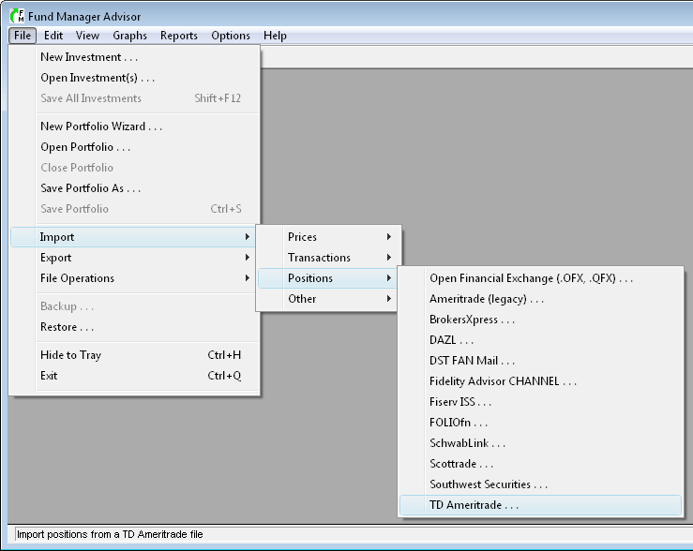
For this tutorial we'll use the "TD Ameritrade" format. This format is available to investment advisors with accounts at TD Ameritrade. Once you select one of these menu commands you'll see the appropriate transaction import dialog:
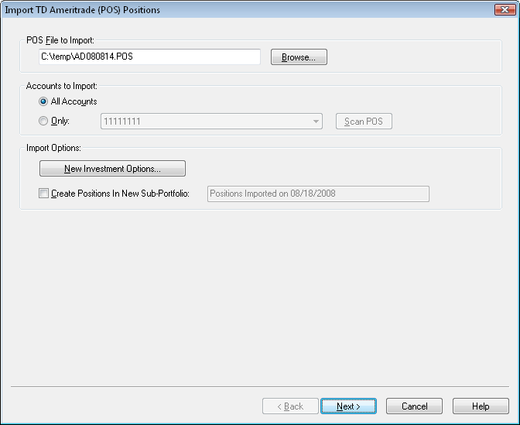
Select the position file you wish to import in the first section.
In the second section you can choose whether to import all available accounts, or only a specific one. We'll import all accounts.
In the "Import Options" section you can specify where to save newly created investments, and whether or not to put all imported positions into a new sub-portfolio. We will leave this option off, to create new accounts right at the top level of the sub-portfolio hierarchy.
Press "Next" to perform the import. The import results will be available for previewing:
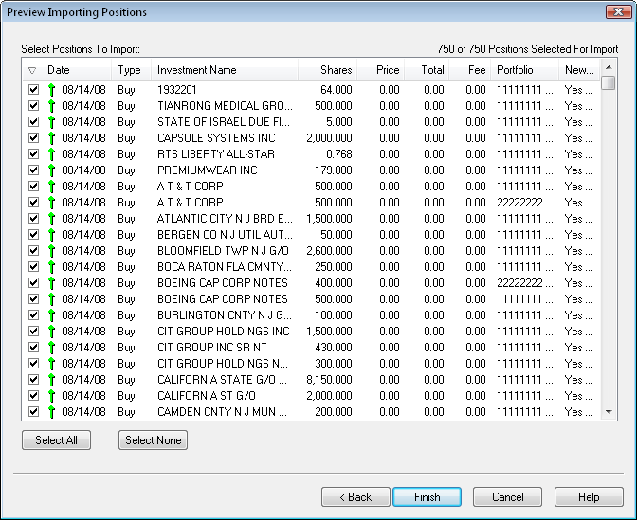
All the positions from the importing file will be displayed. If for any reason you don't want to import one or more positions you can remove the check mark next to that entry. We'll leave them all selected for this tutorial.
When positions are imported they are recorded as "buy" transactions for the date specified in the position file. Some position file formats contain the cost basis for your positions, but some formats do not. If cost basis data is not available in the importing file, the basis will be $0. If you have the cost basis data, you can manually edit these buy transactions later to reflect the correct cost basis.
Press "Finish" to complete the import. For each new sub-portfolio that is being created, you will be prompted for how you would like to handle the default cash account:
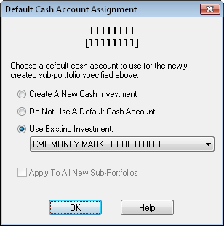
Each sub-portfolio can have its own default cash account assigned to it. When a sub-portfolio has an assigned default cash account, any transactions recorded in that sub-portfolio will automatically have corresponding entries recorded in the cash account. For example, if you buy some shares of an investment, the proceeds will come out of the default cash account. For mutual fund accounts it is usually not necessary to use a default cash account, but for brokerage accounts you usually do want a default cash account.
If you choose the first option: "Create A New Cash Investment" Fund Manager will create a new investment and assign it as the default cash account for the specified sub-portfolio. If you choose the second option: "Do Not Use A Default Cash Account", no cash account will be used for this sub-portfolio. If you choose the third option: "Use Existing Investment" you can pick from any of the existing investments in this sub-portfolio to be the default cash account. You can always modify the default cash account assignment at any later time by selecting the "Properties..." of the sub-portfolio.
Click OK after making your selection, and repeat for each new account/sub-portfolio.
2. Organize Imported Accounts Into Client Sub-Portfolios:
Next, we'll use the Portfolio Editor to organize our imported accounts/sub-portfolios into another level of hierarchy, organized by client. If the Portfolio Editor isn't already open, select "View / Portfolio Editor" to display it:
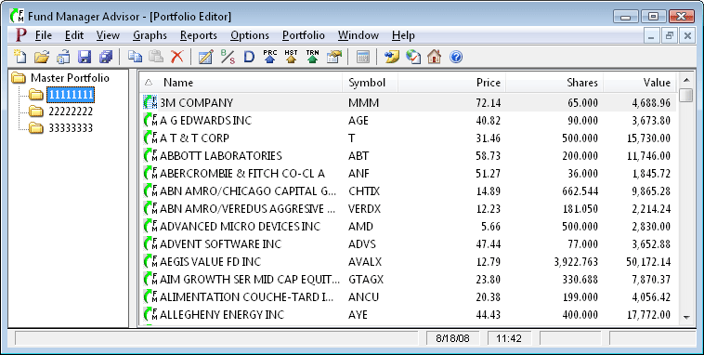
In the above picture the Portfolio Editor window is "maximized", so it is displayed over the whole Fund Manager window. You can minimize, restore, or maximize this window by using any of the buttons in the upper right corner of this window. You can also use the commands under the "Window" menu to organize or arrange all of your open windows. In Fund Manager there are 3 types of windows: Portfolio Editor, Graphs, and Reports. All open windows will be listed under the "Window" menu.
The Portfolio Editor works a lot like Windows Explorer does in Windows. You can create new sub-portfolios, copy or move by dragging/dropping, and copy/paste.
For this tutorial we will assume we have 2 clients: John Smith, and Mary Brown. Accounts "11111111" and "22222222" belong to John, and the account "33333333" belongs to Mary. We must first create sub-portfolios for John and Mary. Right mouse click on "Master Portfolio" to create a new sub-portfolio:
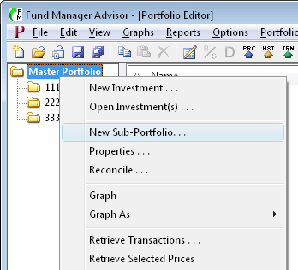
Fill out the "Portfolio Properties" dialog for John Smith's sub-portfolio, like this:
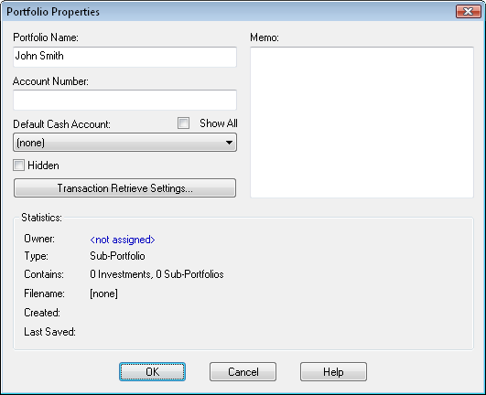
Press "OK" to create the sub-portfolio. Repeat this for Mary by right mouse clicking on "Master Portfolio" and filling out the "Portfolio Properties" dialog again. The Portfolio Editor will now look something like this:
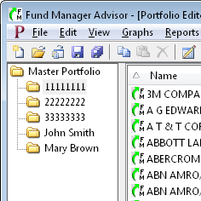
We now want to move accounts "11111111" and "22222222" into John's sub-portfolio, and move account "33333333" into Mary's sub-portfolio. Left mouse click on "Master Portfolio" to select it on the left. This will display the contents of the "Master Portfolio" on the right. Select both "11111111" and "22222222" on the right by left mouse clicking on "11111111" and then hold down the "Ctrl" key while selecting "22222222". You can use the "Ctrl" key to select additional items, or the "Shift" key can be used to select a range of items. When both accounts are selected the Portfolio Editor will look like this:
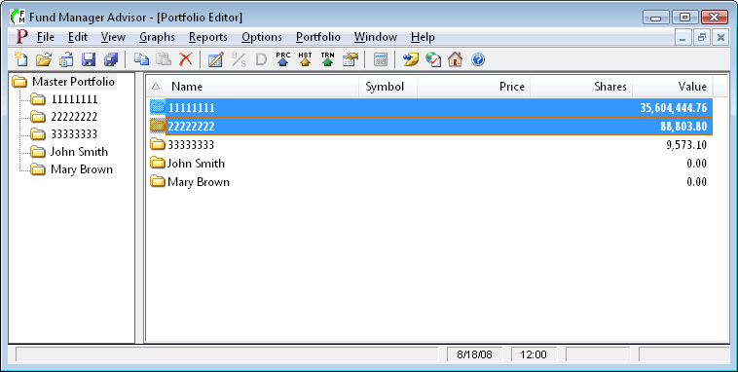
Left mouse click on the selected accounts, and while holding down the left mouse button, drag the accounts over onto the "John Smith" sub-portfolio:
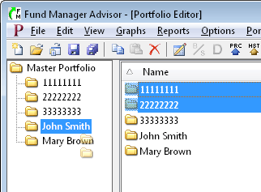
Once the cursor is over John's sub-portfolio, let go of the left mouse button to complete the move of these accounts. (In addition to "moving", you can also "copy" sub-portfolios with drag/drop by holding down the "Ctrl" key).
Repeat this for Mary: Select "Master Portfolio" on the left, select "33333333" on the right, and drag it over onto Mary's sub-portfolio on the left. Your sub-portfolio hierarchy will now look like this:
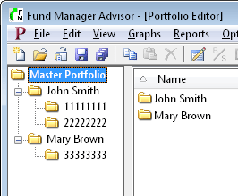
You may also want to edit the sub-portfolio properties of "Master Portfolio" to name it something more meaningful to you, like "My RIA Practice Inc". Organizing your sub-portfolios in this manner allows you to report or graph at any level: account level, client level, or your whole practice.
3. Retrieve Historical Pricing:
We will now update our investments with historical pricing data. Fund Manager can retrieve prices from a variety of quote servers. In order to get historical prices we will select "Yahoo (Historical)" for our historical quote server. Choose "Options / Internet Settings..." from the menu and choose this historical quote server as shown here:
Press OK. To retrieve historical pricing data for all open investments select the menu command "Edit / Internet Retrieve / Historical Prices..." or choose the button on the toolbar.
A dialog will come up asking you for a date range for retrieving historical prices. Enter the dates you would like prices for, and select OK. You will see Fund Manager connect to the quote server and retrieve prices. You can view all the retrieved pricing data in the Data Register.
Once you have historical pricing, use the regular server for obtaining daily quotes. It is best to use a "daily" quote server instead of a historical one for fast retrieves. To retrieve using the regular server select the menu command "Edit / Internet Retrieve / Prices..." or choose the button on the toolbar.
In this tutorial we used the "Edit / Internet Retrieve / Historical Prices..." menu command to retrieve prices for all investments. You can also retrieve prices for only select investments by selecting them in the Portfolio Editor, right mouse clicking, and choosing "Retrieve Selected Prices" or "Retrieve Selected Historical Prices".
Now we will save our data.
Background on Fund Manager Data Files:
There are 2 types of data files used by Fund Manager:
- Investment files
- Portfolio files
Investment files have the file extension of *.dat. Investment files store pricing, transaction, and the properties for that investment. (more info)
Portfolio files have the file extension of *.mm4. Portfolio files store all of your sub-portfolios, which investment files belong in each sub-portfolio, which windows you have open, and all of your options. Portfolio files can be thought of as saving your whole workspace. When you re-open a portfolio file, all of the included investments are also opened. The windows you had open when you last saved the portfolio file are also re-created, and all your settings are restored to their values when you last saved the portfolio file. In short, everything is restored to the same state as when you last saved the portfolio file. (more info)
In many cases you will only need to have a single portfolio file, but you will have many investment files.
Choose the File / Save All Investments menu command to save your investments. Choose File / Save Portfolio As... to assign a portfolio filename and save it.
The next time you start Fund Manager, the last portfolio file you had open will automatically be opened for you. Exit Fund Manager now, by choosing File / Exit. Restart Fund Manager by choosing Start / All Programs / Fund Manager / Fund Manager, and you will see your portfolio again, just as you last left it.
Now that we've created some data let's examine our investments with various reports and graphs:
Reports Tutorial
Graphs Tutorial
See Also:
- Portfolio Editor Tutorial
- Data Register Tutorial

Graphs Tutorial
All graphs are displayed in a "Graphs" window. You can have any number of graph windows open. Each graph window is independent, and displays graphs for its assigned active portfolio.
Fund Manager can have many windows open at once. There are 3 different types of top level windows: Graphs, Reports, and the Portfolio Editor. You can use the top level Window menu command to organize, arrange, or select which window(s) to display. An example Graphs window is shown here:
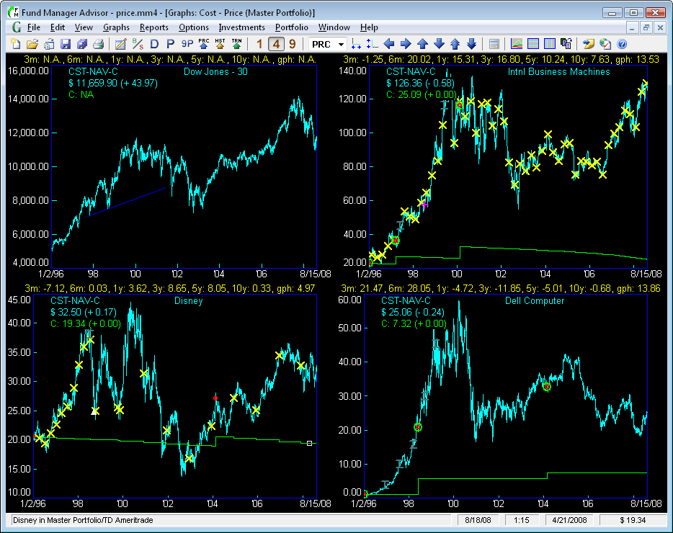
In this example the Cost - Price graph type is selected under the Graphs menu. This is an investment based graph type. There are also many portfolio based graph types. To change the graph type for this window select a new graph type from the Graphs menu. To create a new Graph window select Graphs / New Window....
The number of displays in this example is set to 4. You can change this to 1, 4, or 9 with the toolbar buttons (notice 4 is selected now), or under the View / Number of Displays menu. The "legend" is user-adjustable and is displayed in the upper/left corner of each graph, showing the graph type and the ending share price and cost per share. Yields are being displayed in yellow text above each graph. The share price for this graph type is drawn in light blue, while the out of pocket cost per share is drawn in green. In the title of the window you can see the active portfolio is "Master Portfolio".
Markers are also being displayed. The yellow X's are distributions. Red circles are purchases. The larger green circles are un-specified lots. The white triangles are redemptions. The dark green capital I (eye) bars are splits, and the purple cross is a note marker. The Dow Jones graph is also displaying a dark blue trend line. Control which markers are displayed with the Options / Markers menu commands. As you move your cursor over any marker, information on that marker will be displayed in the status bar. You can right mouse click on any marker to perform operations on it, such as editing the associated transaction.
Cursor snap is currently on, and you can see the small white box on the cost line in the Disney graph on 4/21/2008. The position of this snapped cursor is displayed in the status bar, in the 2 right-most panes. It is displaying the snap position at 4/21/2008 and a cost of $19.34. The current date/time is also displayed in the status bar (8/18/08 at 1:15 in this example).
You can customize the graph type, fonts, colors, date range, vertical scale, display preferences, graph options, or any of several other options available from the menu. Choose which investments are displayed on the investment based graphs under the Investments menu. Set the active portfolio under the Portfolio menu. You can scroll through the investment stack with keyboard shortcuts or the toolbar buttons. You can quickly zoom or pan using keyboard and mouse shortcuts.
Additional graph features are available in the Advisor version. Graphs can be copied as images to the clipboard, for publishing to clients. See Edit / Copy to Clipboard. Graphs (as well as reports) can be emailed to clients using the Send By Email Dialog, or printed in bulk for each client.
See Also:
- Graph Types
- Screenshots of Sample Graphs
- Reports Tutorial
- Portfolio Editor Tutorial
- Data Register Tutorial
- Getting Started Tutorial

Reports Tutorial
Each report is displayed in its own "Report" window.
Fund Manager can have many windows open at once. There are 3 different types of top level windows: Graphs, Reports, and the Portfolio Editor. To create a new report, select a report type from the top level Reports menu. You can have an unlimited number of Report windows open. You can use the top level Window menu command to organize, arrange, or select which window(s) to display. An example Report window is shown here:
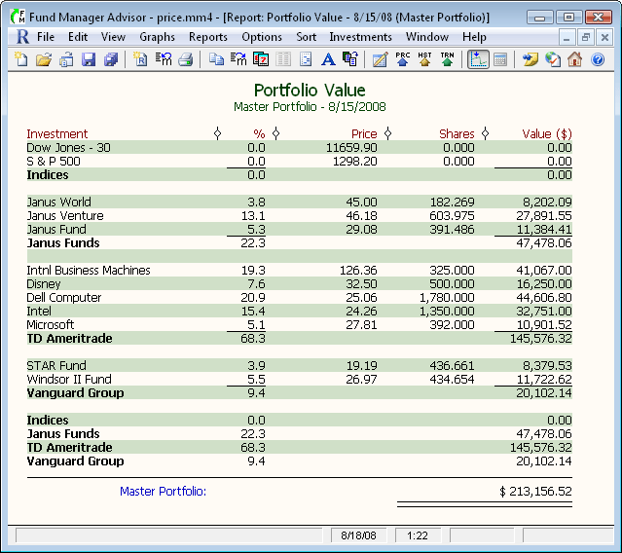
In this example a Portfolio Value report is displayed. This example report is listing by "Investment". You can also list by "Symbol", "Investment Type", "Asset Allocation", "Investment Goal", or “Currency”. This example report is also sub-totaling by sub-portfolio. You can turn sub-totaling off, or sub-total by Sub-Portfolio, Symbol, Asset Type, Investment Goal, or Investment Type. Reports may also be filtered, so they only display a desired Symbol, Asset Type, Investment Goal, Investment Type, or Currency. You can set these options, the date range(s), the report title, or any other report setting in the Report Settings dialog:
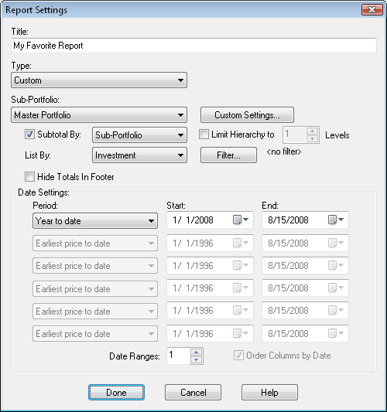
The Report Settings Dialog is displayed when creating a new report from the Reports menu. To modify an existing report, use the menu command Edit / Report Settings... or select the button from the toolbar.
You can resize any report column by clicking and dragging on the column divider: . The report divider for the last column is hidden for appearance purposes, but it is still there, and you can resize this column as well. When your cursor is over any divider the cursor will change to , so you know you can click/drag.
You can customize the report type, fonts, colors, display preferences, or any of several other options available from the menu.
Reports can be sorted by any displayed field. Select the desired sort order from the Sort menu.
Reports can be memorized using the Memorize Report Dialog (Edit / Memorize...). Memorized reports can be recreated by selecting the memorized report name from the bottom of the Reports menu.
The text in any report can be copied to the clipboard using the Edit / Copy Text menu command for use in other applications. Reports may also be exported to CSV files using File / Export to CSV....
Additional report features are available in the Advisor version:
- Reports can be copied as re-sizeable images to the clipboard, for publishing to clients. See Edit / Copy Picture.
- Reports (as well as graphs) can be emailed to clients using the File / Send By Email... command
- Reports (and graphs) can be printed in bulk for each client using File / Batch Print....
- Customize the column labels using Options / Report Column Labels....
- Customize the headers using Options / Report Headers...), You can use mail merge fields to automatically insert values into the headers, like the client's name and/or tax ID.
- Reports can have an adjustable disclaimer displayed at the bottom of the reports (Options / Report Preferences... / Disclaimer).
- Display a logo for your company in the report's header using Options / Report Preferences... / Logo.
See Also:
- Report Types
- Screenshots of Sample Reports
- Graphs Tutorial
- Portfolio Editor Tutorial
- Data Register Tutorial
- Getting Started Tutorial

Data Register Tutorial
The Data Register is where you can enter or modify pricing and transaction data for all your investments. The Data Register is available by choosing Edit / All Data... from the menu or selecting the button on the toolbar. You can also access the Data Register or record any transaction for an investment by right mouse clicking on that investment, and choosing the appropriate menu command. The Data Register looks like this:
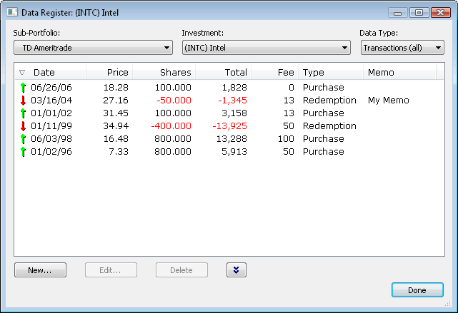
You can work with any investment by choosing the desired Sub-Portfolio and Investment from the boxes along the top.
Under the "Data Type" combo box there are 5 top level data types:
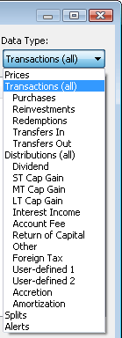
The 5 top level data types are Prices, Transactions (all), Distributions (all), Splits, and Alerts. You can also select one of the sub-categories, like "Purchases", which is a sub-set of "Transactions (all)". Notice the sub-data types are indented. The selected data type specifies what data is being displayed.
Select the data type you wish to work with. For example, to record a new purchase, select either "Transactions (all)" or "Purchases" and then press the "New..." button to record a new transaction. To modify an existing transaction, select it from the displayed data, and choose the "Edit..." or "Delete" button. You can select multiple transactions/prices by using the Shift and Ctrl keys. Transactions and prices can also be copied and pasted by using the right mouse menu or the down arrow button.
Notice the icon in the "Date" column header. This arrow indicates the sort order of the data list. You can control this by clicking on any column's header to sort by that column. Clicking on the same column header again, switches the sort order between ascending and descending. When sorting by ascending, the arrow icon will be facing up, instead of down. You can also adjust the width of any of these columns by clicking and dragging on the edge of any of the column headers. You can also adjust the order of these columns, by using your mouse to drag any column header to a new desired location. Column sizes and order are memorized for future Fund Manager sessions. The initial selection for data type can be customized in the General Preferences - Other Dialog.
See Also:
- Reports Tutorial
- Graphs Tutorial
- Portfolio Editor Tutorial
- Getting Started Tutorial

Portfolio Editor Tutorial
This tutorial uses the Portfolio Editor to demonstrate setting up new sub-portfolios containing the investments of existing portfolio files (*.mm4). This is intended to help convert multiple old portfolios, where no sub-portfolio hierarchy existed, into a single portfolio containing a sub-portfolio for each old portfolio.
Let's assume you have these 3 old portfolios:
TD Ameritrade.mm4
Janus Funds Retirement.mm4
Janus Funds Non-Retirement.mm4
and you want to create a single new portfolio with sub-portfolios for each of these. Let's start off by opening up the existing TD Ameritrade.mm4 portfolio and displaying the Portfolio Editor. Use "File / Open Portfolio..." to open the TD Ameritrade.mm4 portfolio, and then use "View / Portfolio Editor" to display the Portfolio Editor. Your window would look like this:
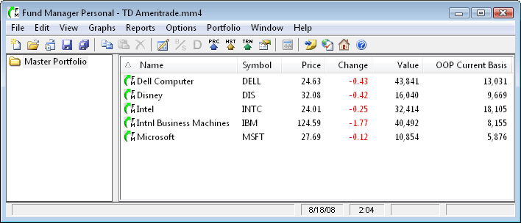
To create our new portfolio file use the "File / Save Portfolio As..." command and assign a new filename to our new portfolio. For this tutorial we have saved the new portfolio as "Family.mm4".
Next, let's create a sub-portfolio for the currently opened TD Ameritrade investments. Right mouse click on the "Master Portfolio" on the left side of the Portfolio Editor, and choose "New Sub-Portfolio..." from the popup menu. Assign the new sub-portfolio a name of "TD Waterhouse" and click OK to the Portfolio Properties dialog. You should see a new sub-portfolio underneath the "Master Portfolio" called "TD Ameritrade".
Let's move all of the open investment files into this new TD Ameritrade sub-portfolio. Select all the investments currently in your Master Portfolio. You can do this by left mouse clicking on the top investment in the list on the right, holding down the Shift key, and left mouse clicking on the bottom investment. Your window should look like this:
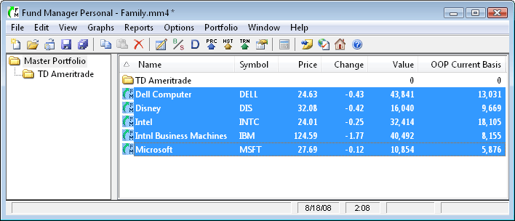
To perform the move, left mouse click on the investments and hold down the left mouse button while moving the mouse over onto the "TD Ameritrade " sub-portfolio. When your cursor is over the TD Ameritrade portfolio your cursor will appear as shown here:
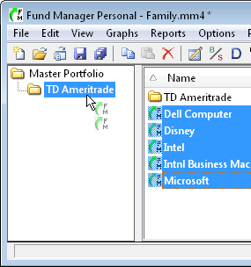
Let go of the left mouse button, and all the selected investments will be moved into the TD Ameritrade sub-portfolio. (On a related note, if you hold down the Ctrl key while dragging the investments you will "copy" the investments instead of moving them. In this case you will see a little plus sign next to the cursor as you perform the drag. This "copy" is just another instance of the same investment file. It does not create a copy of the investment file(s) (*.dat) on your hard drive.)
We have now completed transferring the first old portfolio into a sub-portfolio of a new portfolio file. Next, let's create the other new sub-portfolios we want. For this example, we will create 2 levels of hierarchy for the Janus portfolios. The first level will be for a portfolio called "Janus", and then beneath this sub-portfolio we will have 2 sub-portfolios called "Retirement" and "Non-Retirement". We will also rename "Master Portfolio" to "Jones Family". To do this, right mouse click on "Master Portfolio" and choose "Properties..." from the popup menu. Change the Portfolio Name from "Master Portfolio" to "Jones Family" and hit OK. Create the "Janus" sub-portfolio first by right mouse clicking on "Jones Family" and choosing "New Sub-Portfolio..." from the popup menu. Assign the name as "Janus" and hit OK. Right mouse click on "Janus" and choose "New Sub-Portfolio..." and assign a name of "Retirement". Again, right mouse click on "Janus" and choose "New Sub-Portfolio..." and assign a name of "Non-Retirement". Your Portfolio Editor should now look like this:
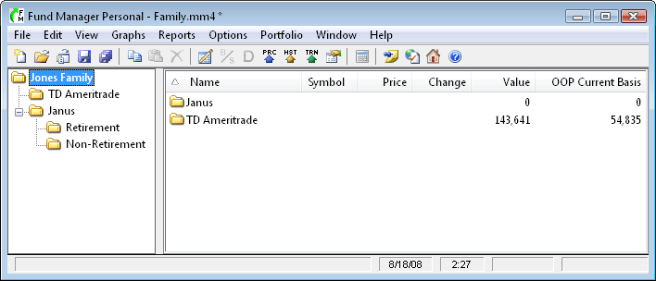
Let's save our work by choosing "File / Save Portfolio".
Now, let's add the investments from the Janus Funds Retirement.mm4 portfolio into the appropriate new sub-portfolio we just created. To do this, we will copy from the old portfolio and paste into the new sub-portfolio.
Use "File / Open Portfolio..." to open the Janus Funds Retirement.mm4 portfolio, and then use "View / Portfolio Editor" to display the Portfolio Editor. If your portfolio contains hidden investments that you want to transfer turn on "View / Hidden Investments" so they are visible in the Portfolio Editor. Select all the investments open in this portfolio using the same technique as before. On the right hand side of the Portfolio Editor, left mouse click on the top investment, hold down the Shift key, and left mouse click on the bottom investment. All your investments should be selected. Choose the menu command "Edit / Copy" to copy the selected investments to the clipboard. Your window should look like this:
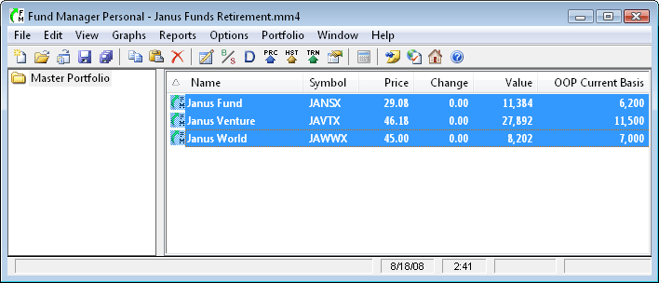
Use "File / Open Portfolio..." to open the Family.mm4 portfolio. In the Portfolio Editor select the "Retirement" sub-portfolio we created earlier. Use the menu command "Edit / Paste". This will add the just copied investments into this selected sub-portfolio. Your window should look like this:
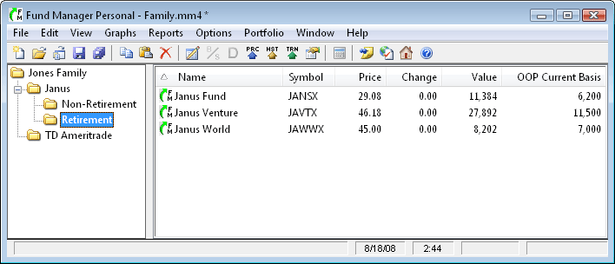
Save your portfolio using "File / Save Portfolio".
Repeat this same procedure for the Janus Funds Non-Retirement.mm4 portfolio. Open that portfolio, select all the investments in the Portfolio Editor, copy them to the clipboard, re-open the Family.mm4 portfolio, select the Janus Non-Retirement sub-portfolio, and paste the investments into that sub-portfolio.
That's it, you've transferred all your investments from the 3 old portfolios into 1 new portfolio with sub-portfolios. If you've ever used Windows Explorer before you will notice that the Portfolio Editor works in much the same way. We used copy/paste to transfer investments across portfolio files. You can also use copy/paste to transfer entire sub-portfolio hierarchies as well. This tutorial also demonstrated how to create several sub-portfolios. You can create as many sub-portfolios as you'd like, and they can have unlimited hierarchy. Your portfolio file (*.mm4) saves all your sub-portfolios along with which investments are contained in each sub-portfolio.
For additional reading consult the online documentation. In particular, browse the contents to:
Using Fund Manager / Portfolios
User Interface / Windows / Portfolio Editor
See Also:
- Getting Started Tutorial
- Graphs Tutorial
- Reports Tutorial
- Data Register Tutorial

Multiple Currency Tutorial
Fund Manager can track investments in up to 25 different currencies. Currency settings are specified in the Currency Settings Dialog. Currency settings include:
- symbol to display for each currency
- your default currency
- exchange rate between each currency and your default currency
The exchange rate can either be a fixed ratio, or assigned to an "exchange rate" investment. Using an exchange rate investment offers greater accuracy, as the exchange rate can vary with time. This tutorial will demonstrate creating and assigning an exchange rate investment. Fund Manager can then display your investments in either their native currency or your default currency using the "View / Exchange Rate Adjusted" menu command.
Let's assume your default currency is US dollars, and you also own investments bought/sold in Canadian dollars. First, we need to create an exchange rate investment to track the exchange rate between Canadian and US dollars. Looking up the exchange rate on Yahoo we find the symbol that describes the number of Canadian dollars for 1 US dollar is USDCAD=X. Create a new investment similar to this:
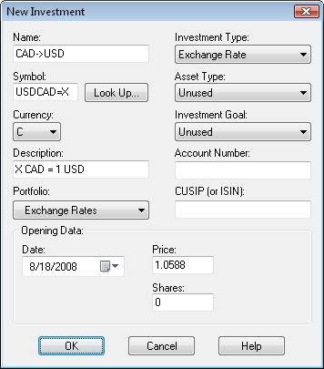
Next, we need to assign this exchange rate investment to be used by Fund Manager for converting between Canadian dollars and US dollars. Select "Options / Currency Settings..." and set the options similar to this:
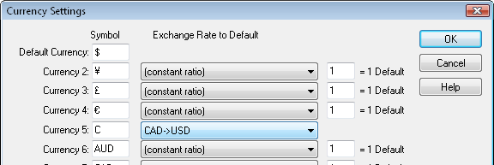
The closing price for this exchange rate investment (CAD->USD) will be used to convert from Canadian to US dollars.
Every investment has a currency property that can be set when creating the new investment, or adjusted from within the Investment Properties dialog. All prices and transactions are always entered in an investment's native currency.
The menu command "View / Exchange Rate Adjusted" controls whether investments are displayed in their native currency or in the default currency. For example, the following report was created with this option OFF:
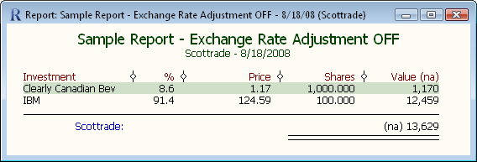
and this same report is shown with the View / Exchange Rate Adjusted option ON:
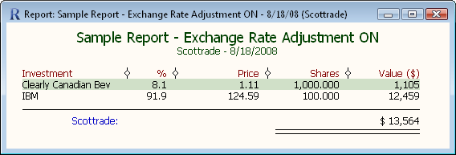
In this example the "Clearly Canadian Bev" investment's native currency is Canadian dollars, and the "IBM" investment's currency is US dollars (our assigned default currency). In the first report both investments are displayed in their native currency. In the second report the Canadian investment is converted and displayed in our default currency. Since the exchange rate adjustment investment (USD->CAD) has a recorded closing price on 8/18/2008 of 1.0588 the Canadian dollar value of 1,170 becomes 1,105 when displayed in our default currency (1170 / 1.0588 = 1105).

